Scenario 1: Bicycle Manufacturing

A small company manufactures customized bicycles. Whenever the sales department receives an order, a new process instance is created. A member of the sales department can then reject or accept the order for a customized bike. In the former case, the process instance is finished. In the latter case, the storehouse and the engineering department are informed. The storehouse immediately processes the part list of the order and checks the required quantity of each part. If the part is available in-house, it is reserved. If it is not available, it is back-ordered. This procedure is repeated for each item on the part list. In the meantime, the engineering department prepares everything for the assembling of the ordered bicycle. If the storehouse has successfully reserved or back-ordered every item of the part list and the preparation activity has finished, the engineering department assembles the bicycle. Afterwards, the sales department ships the bicycle to the customer and finishes the process instance.

Visualize this business process using BPMN.

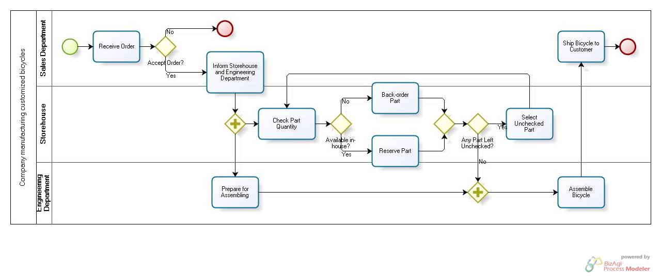
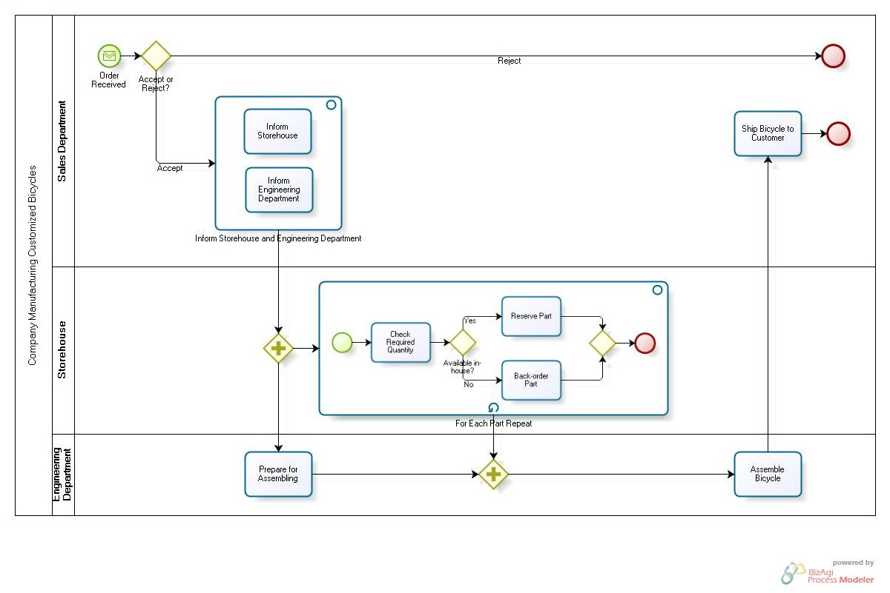
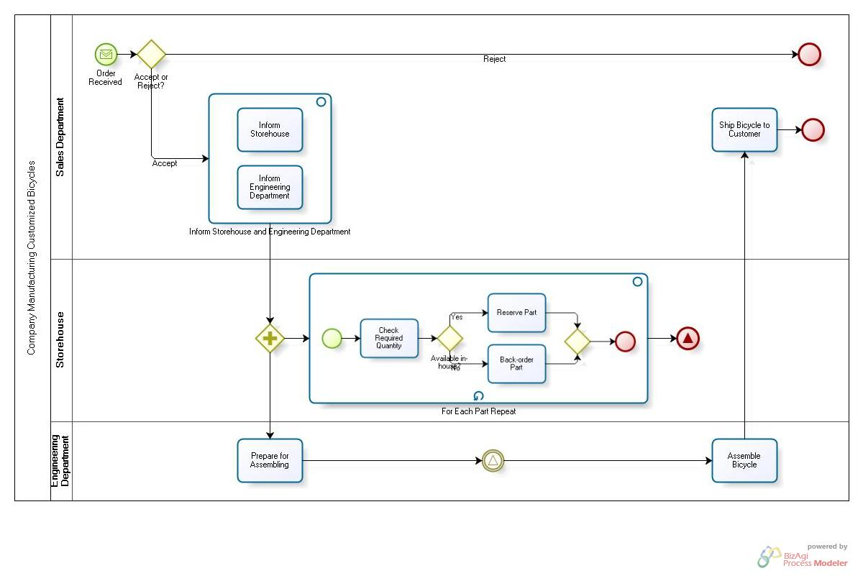

Scenario 2: Computer Repair

The workflow of a computer repair service (CRS) can be described as follows. A customer brings in a defective computer and the CRS checks the defect and hands out a repair cost calculation back. If the customer decides that the costs are acceptable, the process continues, otherwise she takes her computer home unrepaired. The ongoing repair consists of two activities, which are executed, in an arbitrary order. The first activity is to check and repair the hardware, whereas the second activity checks and configures the software. After each of these activities, the proper system functionality is tested. If an error is detected another arbitrary repair activity is executed, otherwise the repair is finished.

Visualize this business process using BPMN.

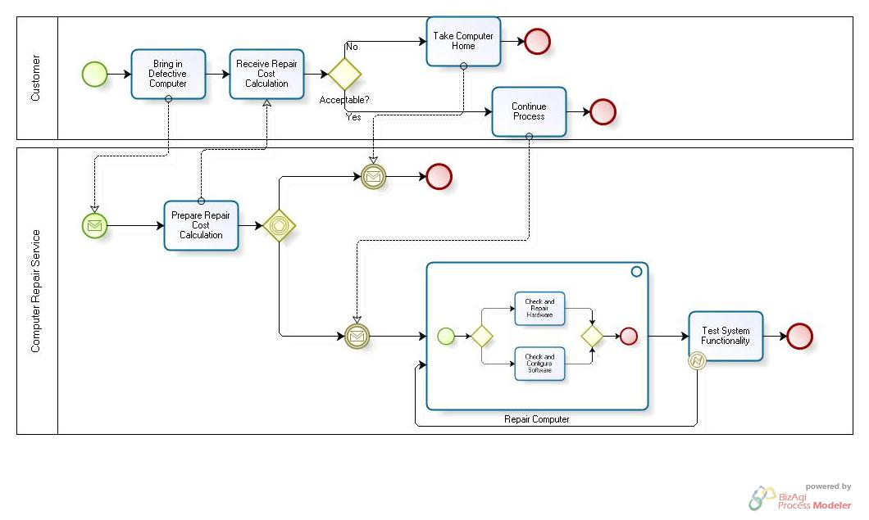

Scenario 3: Hotel Service

The Evanstonian is an upscale independent hotel. When a guest calls room service at The Evanstonian, the room-service manager takes down the order. She then submits an order ticket to the kitchen to begin preparing the food. She also gives an order to the sommelier (i.e., the wine waiter) to fetch wine from the cellar and to prepare any other alcoholic beverages. Eighty percent of room-service orders include wine or some other alcoholic beverage. Finally, she assigns the order to the waiter. While the kitchen and the sommelier are doing their tasks, the waiter readies a cart (i.e., puts a tablecloth on the cart and gathers silverware). The waiter is also responsible for nonalcoholic drinks. Once the food, wine, and cart are ready, the waiter delivers it to the guest’s room. After returning to the room-service station, the waiter debits the guest’s account. The waiter may wait to do the billing if he has another order to prepare or deliver.

Visualize this business process using BPMN.

Source: R. Anupindi et al.: Managing Business Process Flows. 2nd Edition, 2006, 340 p., Pearson Prentice-Hall, Upper Saddle River, NJ, USA.

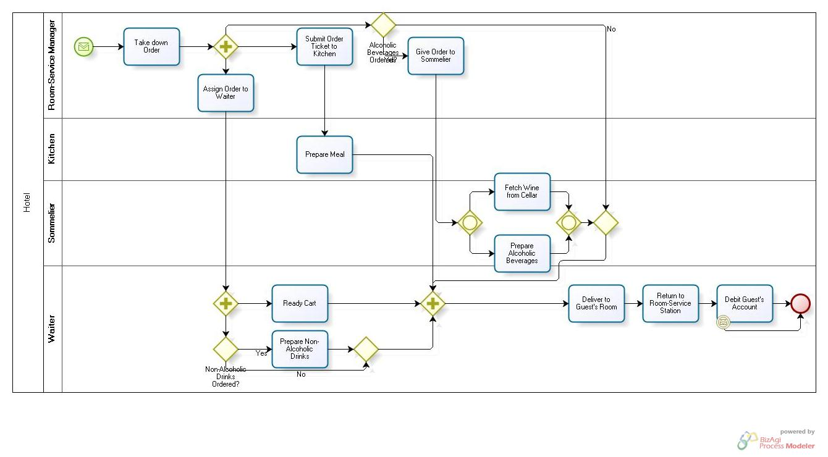

Scenario 4: Underwriters

Whenever a company makes the decision to go public, its first task is to select the underwriters. Underwriters act as financial midwives to a new issue. Usually they play a triple role: First they provide the company with procedural and financial advice, then they buy the issue, and finally they resell it to the public.

Established underwriters are careful of their reputation and will not handle a new issue unless they believe the facts have been presented fairly. Thus, in addition to handling the sale of a company’s issue, the underwriters in effect give their seal of approval to it.

They prepare a registration statement for the approval of the Securities and Exchange Commission (SEC). In addition to registering the issue with the SEC, they need to check that the issue complies with the so-called blue-sky laws of each state that regulate sales of securities within the state. While the registration statement is awaiting approval, underwriters begin to firm up the issue price. They arrange a road show to talk to potential investors. Immediately after they receive clearance from the SEC, underwriters fix the issue price. After that they enter into a firm commitment to buy the stock and then offer it to the public, when they haven’t still found any reason not to do it.

Visualize this business process using BPMN.

Source: Brealey/Myers/Allen, Principles of Corporate Finance, 9th ed., 2008.

